|  |  |
| --- | --- |
| **Name:- Aryan Dilipbhai Langhanoja** | **Roll Number:- 92200133030** |
| **Subject Name and Code:-** Foundation Skills On Sensor Interfacing (01CT1103) | **Date of Experiment:- 17-12-2022** |

|  |  |
| --- | --- |
| Task:- |  |

Interface LDR with arduino and control the brightness of LED accordingly.

|  |  |
| --- | --- |
| Components: |  |

* Arduino Uno R3
* LED
* Jumper Wires (Male To Male)
* Light Dependent resistor LDR Sensor.
* Bread Board
* Laptop Or PC

|  |  |
| --- | --- |
| About the Project:- |  |

* In thisproject, we are going to Interface LDR Sensor With Arduino. LDR sensor has three pins. In That There is one pin Named VCC which is connected to +5V of Arduino. One pin ground which is connected with GND pin Of Arduino. And middle pin is output pin Which is connected to analog pin A0 of Arduino.
* LDRs are **tiny light-sensing devices also known as photoresistors**. An LDR is a resistor whose resistance changes as the amount of light falling on it changes. The resistance of the LDR decreases with an increase in light intensity. This property allows us to use them for making light sensing circuits.

|  |  |
| --- | --- |
| Output (you circuit implementation):- |  |

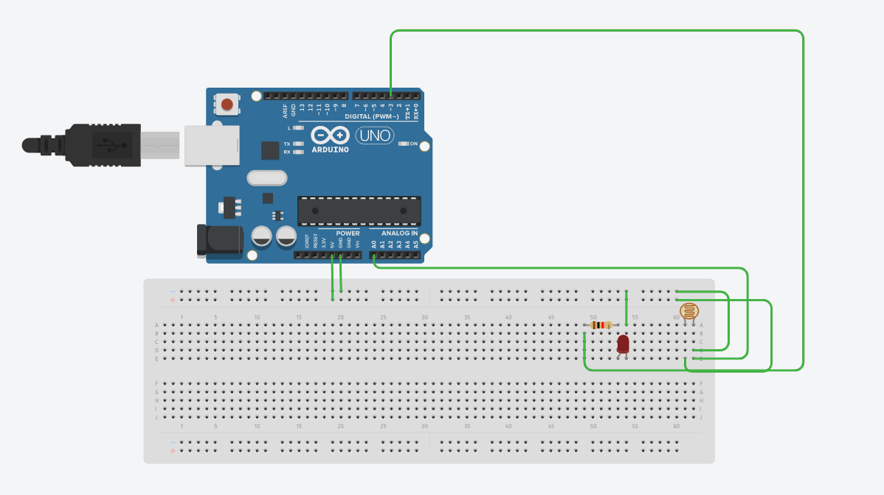

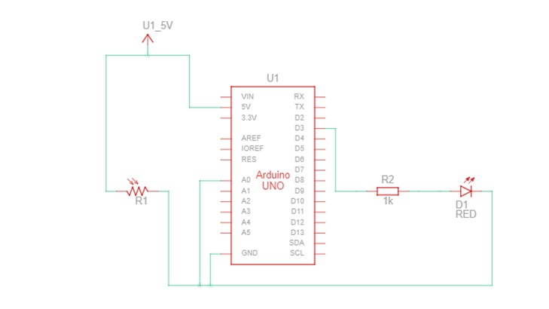

|  |  |  |
| --- | --- | --- |
| Schematic:- |  |  |

|  |  |
| --- | --- |
| Application:- |  |

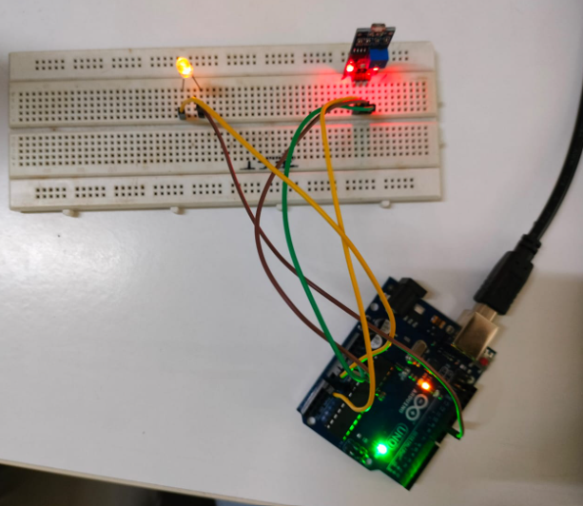

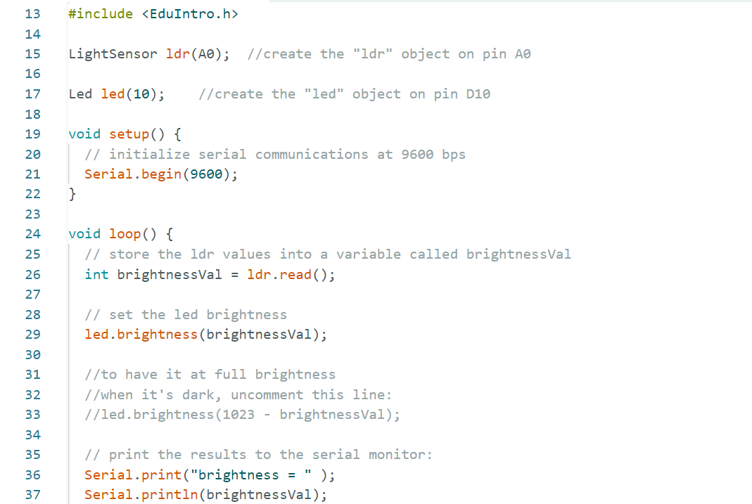

|  |  |
| --- | --- |
| Code:- |  |

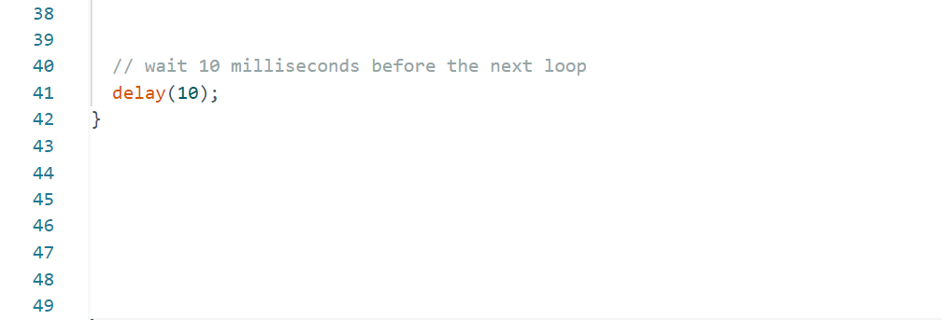

|  |  |
| --- | --- |
| Reading Of Serial Monitor:- |  |

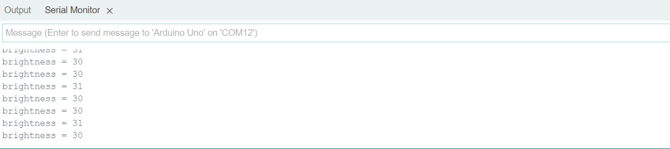

|  |  |
| --- | --- |
| Conclusion:- |  |

* In This Experiment, We Learnt That How to Interface LDR Sensor with Arduino Uno.